**Ideation Phase**

**Empathize & Discover**

|  |  |
| --- | --- |
| Date | 26 June 2025 |
| Team ID | LTVIP2025TMID30678 |
| Project Name | To Supply Leftover Food to Poor |
| College Name | Ideal Institute Of Technology |
| Team members | 1. Sadi ramana (Leader) – 22MH1A04D6 2. Sravani kasireddy(Documentation developer and opearator ) - 23MHA0412 |

**Empathy Map Canvas:**

An Empathy Map Canvas is a useful tool for identifying the needs, emotions, and experiences of the target audience, in this instance, those individuals and families experiencing food insecurity and who would be helped by the provision of excess food. Here's how you can organize an Empathy Map for this project:

Empathy Map Canvas:

1. Who are we empathizing with?

- Target Audience: Low-income individuals and families that are food insecure.

2. What needs to happen?

- Regular access to healthy foods.

- Breaking down barriers to food access.

- Felling valued and supported by their community.

3. What do they observe?

- Food in restaurants and supermarkets that is being wasted.

- Few choices for affordable, healthy meals.

- Community resources that are not widely publicized or accessible.

4. What do they hear?

- Discussions of hunger and food insecurity within the community.

- Knowledge of food donation programs, but perhaps with limited explanation of how to access them.

- Accounts of others who have received food assistance.

5. What do they say and do?

- Report concerns of not having sufficient food for their own families.

- Turn to local community organizations or food banks for assistance.

- Take part in outreach programs or community activities when notified.

6. What do they think and feel?

- Anxiousness and stress regarding not having food.

- Worry regarding their family's health and wellbeing.

- Hope for help from the community and solutions to food insecurity.

- Possible embarrassment or stigma associated with seeking food assistance.

7. Pain Points

- Difficulty accessing food distribution points due to transportation issues.

- Lack of awareness about available resources and programs.

- Concerns about the quality and safety of donated food.

- Stigma associated with receiving food assistance.

8. Gains

- Enhanced access to healthy food.

- Greater community support and involvement.

- Reduced food waste and more sustainable food system.

- Greater sense of dignity and empowerment through food support.

Visual Representation:

To make a visual Empathy Map Canvas, you can employ a huge piece of paper or an online tool such as Miro or Canva. Split the canvas into sections according to the above categories, and complete each section with findings from interviews, surveys, or community input.

**Empathy Map:**

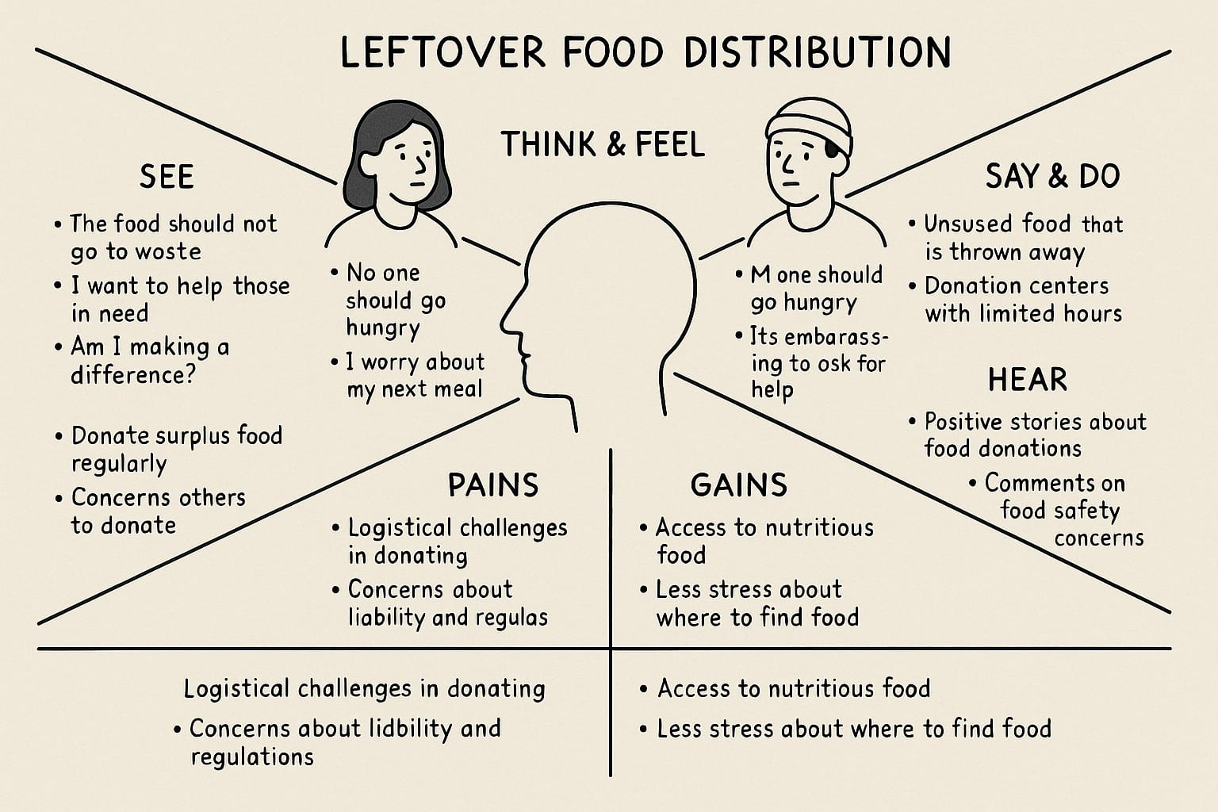

**Food Ordering & Delivery Application:**

